**Stock Market Forecasting with Long Short- Term Memory Models**

Pankaj Kandari

*Department of Computer Science and Engineering*

*Graphic Era Hill University*

*Dehradun, Uttarakhand, India*

*pankajkandari810@gmail.com*

**ABSTRACT:** Accurate prediction of stock prices is a very challenging task due to volatile and non linear nature of financial stock. Thus to maximize the profit and minimize the losses, technique to predict values of stock in advance by analyzing the trend over last few years. This research paper covers a approach for predicting stock prices ,aiming to estimate the stock price of a particular stock of the following day based on its past 50,100,200 days of historical stock data that includes it’s open price, close price, low, high and volume. This model is trained to read and analyse patterns withing given time series data using layers of Long Short-Term Memory(LSTM) cells.

LSTM cells represents the memory of network, storing information over time while discarding the irrelevant information. Dropout layers technique are used in this model to improve the LSTM networks by reducing overfitting. This paper is about to discuss different techniques related to the prediction of stock market.

Results. The results further reveal that the LSTM model is able to achieve high prediction accuracy when tested on unseen data by means of RMSE and MAPE metrics, and the predictions closely occur with the real stock prices, as shown by comparing graphs.

In conclusion, it shows that this study is effective in short-term stock price forecasting using LSTM-based models with advantages over conventional machine learning techniques. Thus, providing a reliable decision-making tool for investors and analysts is a good advantage.

___________________________________________________________________________________________

# **INTRODUCTION**

# Stock market is observed to be highly dynamic, uncertain and non-linear in its own nature. The prediction of stock prices is a hard task, as it is based on several factors that can impel the situation respectively through political issues, the global economy, company's financial results and its performance. Therefore, to maximize the profit and minimize the losses, the value of the stock can be predicted in advance by studying the trend over the last few years which could prove to be quite useful for stock market movements

# It is well known that at least two factors of the future rate are subject to prediction. The company is required to release a series of reports for these predictions to be made before they can be made. A report, such as the update to the yearly operating projection, will provide a general picture of the company’s situation, which is a sufficient basis for the forecasting of the company’s share price. On the other hand, using the financial tuning method, one cores the times days have happened of (times 1000). A simple systematics shows that the stock price gets up or down on the number of the previous year’s quarter in the corresponding time interval.

# In this chapter we will investigate a model that is built in layers consisting of LSTM cells.

# A different type of cell in the recoding process is the one that that the neural network has been developed to work particularly well with data that comes in series, e.g. days and the prices

# of stock on those days.

# They are given the name “Long Short-Term Memory” in that they are able to keep the important information of the past time for a long time while throwing away any irrelevant notes. It is not necessary to know everything about a stock to be able to predict its future price. As an example, you only must acknowledge the trends that are relevant to you such as last few days or weeks when you want to calculate the cost of a particular stock.

# The LSTM network models have seen a boom over the past few years as a hot research area.The LSTM Neural Network is a type of deep neural network model that can selectively learn and remember information about time series data, which is a very useful model for the non-stationary sequential data like stock price time series. LSTM network is considered one of the most accurate forecasting techniques.

# The studies mainly focus on the LSTM neural network used in finance and there are a lot of them at present. LSTM network models have distinguished themselves as a much-studied research issue in the last few years. The neural network called LSTM is endowed with the characteristic of selective memory and intra-temporal influence, therefore, it is a proper tool for the non-stationary nature of the stock price time series. Prediction using an LSTM network is the most accurate forecasting technique among others. A lot of studies are running in the area of LSTM neural network applications in finance.

# In this study, I have adopted the LSTM techniques to teach the model, LSTM, by specifying the prediction timeline and using the default Yahoo finance stock market historical data from 1/1/2014 to today’s date, which was the original data for short-term prediction. The models are evaluated using root mean square error (RMSE) and mean absolute percentage error (MAPE).

# The main goal of this article is to check how correctly the LSTM neural network models are applied to the short-term prediction ranges and to determine whether the LSTM model displays some paybacks in comparison with other machine learning algorithms in the domain of the stock market.

# **LITERATURE REVIEW**

# Using LSTM in stock price prediction a very difficult challenge of artificial intelligence. This is due to unstable, non-linear, and dynamic nature of the financial market. The traditional techniques such as ARIMA and regression models are less efficient because they cannot capture well the nonlinear and temporal dependencies inherent in financial data. Over the past few years, Long Short-Term Memory (LSTM) networks, which is a type of Recurrent Neural Networks (RNNs), has shown to be a very impactful tool in time series forecasting. LSTM, in particular, is attached to modeling of the time sequence so that it fixes the major problems associated with the traditional RNNs like disappearing and multiplying gradient. This review paper collates information from significant research studies about LSTM based stock price prediction, the developments, difficulties, and prospects for the future.

# **LSTMs in Financial Market Predictions**

# Fischer and Krauss (2018) paper studied the application of LSTMs in financial markets with a focus on the stock returns from the S&P 500 index. The research claimed that the models based on machine learning outperformed the traditional regression models after comparison with stock returns (from the S&P 500 index). In this way, the superiority of LSTMs in long-term dependencies and complex time-dependent pattern modeling in the financial data over the logistic regression models was proven. By exploiting their memory cells and gating mechanisms, LSTMs success in handling sequences of stock returns was enhanced, and their predictive accuracy was improved, making them as good as traditional statistical models. The research focused on LSTM of how it outperforms traditional statistical models and how to make it a strong tool for financial forecasting.

# **Enhancements Using Attention Mechanisms**

# LSTM performance was made even better by introducing attention mechanism, a method in which Zhang, Aggarwal, and Maheshwari (2020) assigned different levels of importance to different steps according to their relevance. In a financial market filled with uncertainty, stability, and predictability are not observed, the past occurs to be more important than other past data points. The attention mechanism involves the LSTM to place its focus on these crucial points, resulting in it being better at handling it, hence, the higher accuracy of stock prices forecast.

# **Hybrid Approaches Combining LSTMs with Technical Indicators**

# Patel et al. (2015) offered a hybrid approach that fitted LSTM nets with various machine learning methods (like Moving Averages, Bollinger Bands, and Relative Strength Index), and technical indicators. These were the tools that allowed the LSTM model to correctly deal with both temporary as well as non-temporary relationships in stock data. The hybrid model was better than the LSTM stand-alone model and the machine learning models, which thereby stressed that the advantages of integrating some complementary techniques are abundantly obvious. This method, as well, displayed the significant role of feature engineering in increasing the model's performance and, subsequently, robustness in financial forecasting.

# **Comparative Analysis of LSTMs and Other Deep Learning Models**

# Selvin et al. (2017) performed a comparative study on LSTMs, CNNs (Convolutional Neural Networks), and traditional RNNs for stock price prediction. CNNs outperformed the LSTMs in detecting spatial relationships, however, they suffered from sequential dependencies, which is a crucial aspect of time-series data. On the other hand, RNNs experienced problems like vanishing gradients and therefore lost their capability to model long-term dependencies. LSTMs because of their architecture that addressed these issues were the best-performing model, besides an additional sliding window preprocess was also used by the researchers, and that enhanced the LSTM's performance by a good margin by organizing the input sequences in a more efficient way.

# **Incorporating Sentiment Analysis with LSTMs**

# Ghosh and Ghosh (2021) developed the LSTMs by extending them with the sentiment analysis, which was taken from financial news and social media. The hybrid model that they used made it possible for the textual data the model had to not only determine the market sentiment but to also unite it with historical stock price trends too. It was found that by taking sentiment into account, apart from the LSTM model working correctly, the accuracy of the model in the market was very high all along the way. Thus, this asset made it clear that the data coming from the outside in an unstructured way is something more than essential for the forecasts of the stock prices.

# **Key Insights and Challenges**

# The combined investigations demonstrate flexibility and robustness of LSTMs in stock price prediction, a very important scenario for financial institutions and individual investors. These networks outstand the most in the following areas, interpreted as they are: keeping track of the temporal order of the data and dealing with non-linearities. They also are able to address the challenging issue of noisy and complex input data. Following this line, the inclusion of attention mechanisms, hybrid models, and sentiment analysis makes them even more powerful in predicting.

# At the same time, there are several issues that need to be addressed anyway. Overfitting is the most significant problem when training LSTMs and often happens when you have a small dataset. Computational complexity is another hurdle as LSTMs take a lot of resources when training with big data sets. Moreover, the black-box nature of LSTMs makes it hard to interpret, which results in people not being able to understand why a certain decision has been made. Those key can be addressed to allow for a total takeover of the product.

# **Future Directions**

# The forthcoming studies about the LSTM-based stock price prediction may look for ways to diminish the previously described insufficiencies in new projects. Developing LSTMs' explainable AI (XAI) can also increase the users' trust and ease area. Utilizing what is usually referred to as up-to-date data, macroeconomic variables and smart algorithms such as transformers will follow the approach of best forecasting accuracy. Besides, running the ensemble models of LSTMs with the other traditional algorithms such as Gradient boosting and Decision trees will cover a wide range of the technical possibilities instead only trying out one direction.

# Scalability is another area that requires a lot of attention. By employing LSTMs in the multi-stock portfolios, and by implementing the current extensive use of financial instruments like cryptocurrencies and commodities, a new outlook is founded. Also, a search for an encouraging solution to regular users, including a cloud-based system, in order to make the application of LSTM-based models less expensive is needed.

# **Conclusion**

# LSTM networks have been able to forecast stock price in a way not possible with traditional methods. Innovations in this field such as long-term dependencies and attention mechanisms as well as sentimental analysis have finally brought LSTMs to the forefront of this up-to-date tech. More primary work in this area, especially on scalability, interpretability, and resource efficiency will further enable the LSTM model to be used to foresee complicated financial phenomena.

# **METHODOLOGY**

* **DATASET:**

**Description of data**: The historical data of all the companies listed in stock market has been collected from Yahoo Finance. The dataset includes the last 10 years data of the selected stock from 1/1/2014 to 1/10/2024 that is of user’s choice. The data contains information about the stock such as Adjacent close, low, high, close price, open price and volume.

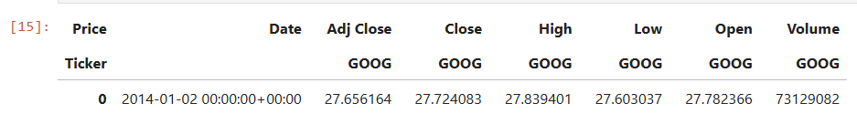

N

Figure 1 Preview of information of a stock

In this model, the data is divided into a training set and a testing set based on an 80-20 split of the time period from 1/1/2014 to 1/10/2024. In this time interval the data is divided as following.

* **Training data**: January 2014 to November 2022(approx. 80% of dataset)
* **Testing data**: November 2022 to October 2024(approx.. 20% of dataset

The dataset ensures a balance between training the model on historical trends and testing its ability to generalize to new, unseen data. Moving averages (50-day, 100-day, and 200-day) are calculated to offer additional insights into short-term, medium-term, and long-term trends, further enriching the dataset. Preprocessing steps, such as normalization, are applied to scale the data for efficient training. This ensures that all features contribute equally to the model's learning process, avoiding biases due to differences in magnitude.

## 

## Training Model using LTSM:

In this stage of model training, the data is processed through Neural Network and trained for prediction for the remaining 20% of the dataset.

The model is arranged in layers which contain LSTM cells. These types of cells are a kind of neural network layer that has been designed to work well with data that comes in series, such as days and the prices of stock on those days.

The model comprises various levels where each level performs a task and collectively helps in coming up with predictions of the stock.

LSTM Layers: Consider these levels as those that detect and understand the presence of particular pattern. Every LSTM layer processes the price data for 100 days and tries to find some relation, for example, whether pricing tends to go up after a specific order. The LSTM layers consider time-series data by retaining the relevant information and discarding the rest. Each succeeding layer refines the preceding one and detects trends ranging from the simple to complex. Dropout layers are added to prevent overfitting and improve generalization, making sure the model works fine on new data that was not encountered before. Finally, dense layers are added to take the extracted features and make them practical predictions, such as the next day's stock prices.

The performance of the LSTM model is evaluated in terms of metrics such as Mean Absolute Percentage Error (MAPE) and Root Mean Squared Error (RMSE). The closer these are to zero, the more accurate the model is.

Once the model is trained, its predictions are validated by comparing predicted prices with actual stock prices, which are visualized graphically for interpretability.

The first layer has the extremely raw data for the past 100 days and starts to hold on simplistic trends.

Following layers are built upon the trends of the former layers and are designed to get more detailed interrelations. The deeper we go in the layers, the more the model can interpret how the price changed with time.

Dropout Layers: These layers are useful to enable the model to perform well by preventing it from learning specific features in the training data. Dropout is like preparing to sit for an examination by not learning everything word for word but knowing terms that can help to answer the questions. Dropout layers prevent the model from overfitting to the training data by taking out portions of the training neural network for each iteration. This is because the model becomes too regular to recognizing specific patterns that may not be present in new data, thus ‘dropping out’ helps to avoid this.

Dense Layer: A Dense layer is typically added after the LSTM layers to take the processed sequence data and make the final prediction. For example, in this stock prediction, the Dense layer would take the LSTM output and produce a single number (like the next day's predicted price) or multiple outputs (if predicting more than one future time point).

In addition to these, the model takes the help of moving averages ranging from 50-day to 100-day and 200-day to understand trends with a different time frame for short-term, medium, and long-term fluctuations that allow the model to predict a situation better.

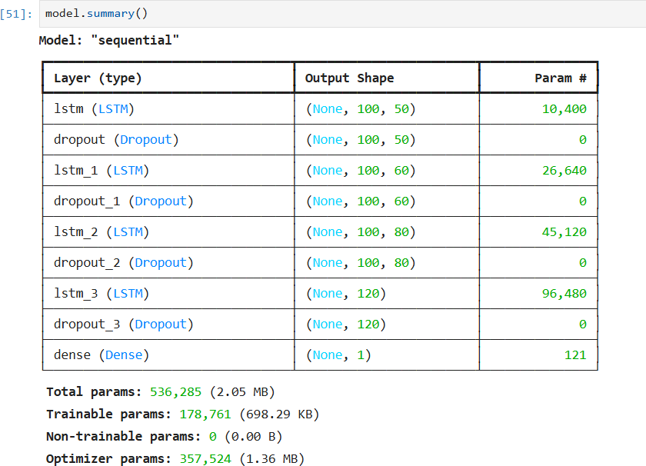

Figure 2 Model Sequential Summary

* **Feature’s:**

In the model ,it uses three graphs of Moving averages(MA) against closing price to the stock to help users to understand the stock price trends over different time periods. Each graph shows the actual closing price of the stock along with moving averages calculated over different periods (50 days, 100 days, and 200 days).The information about graphs are following:

* **Price vs. 50-Day Moving Average (MA50):** The graph shows 50-day moving average against closing price over a specific time period. It represents the average price of the stock over the last 50 days. Since it’s a shorter moving average, it reacts more quickly to recent price changes.

This graph helps users see short-term trends and the recent momentum of the stock price. If the stock price is consistently above the 50-day moving average, it may indicate bullish (upward) momentum and vice versa.

## Price vs. 50-Day and 100-Day Moving Averages (MA50 vs. MA100): This graph represents the 100 days moving average. It is less sensitive to recent fluctuations than the 50-day MA and more responsive to the overall trend over a slightly longer period. By plotting both the 50-day and 100-day moving averages, users can observe the pattern between short-term and medium-term trends. When the 50-day MA crosses above the 100-day MA, it is often seen as a bullish signal, indicating potential upward momentum. When the 50-day MA crosses below the 100-day MA ,it could signal a bearish trend.

## Price vs. 100-Day and 200-Day Moving Averages (MA100 vs. MA200): This graph represents the long-term trend movements of 100 and 200 day MA. This graph helps users identify longer-term trends. The 200-day moving average is often used by investors to understand the stock’s fundamental strength.

Figure 5 Line Graph b/w Price and MA100 and MA200

Figure 3 Line Graph b/w Price and MA50

Figure 4 Line Graph b/w Price and MA50 and MA100

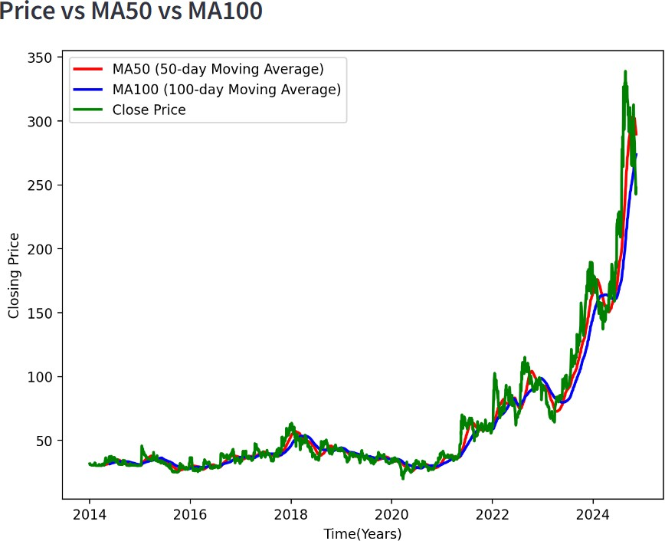

Figure 2

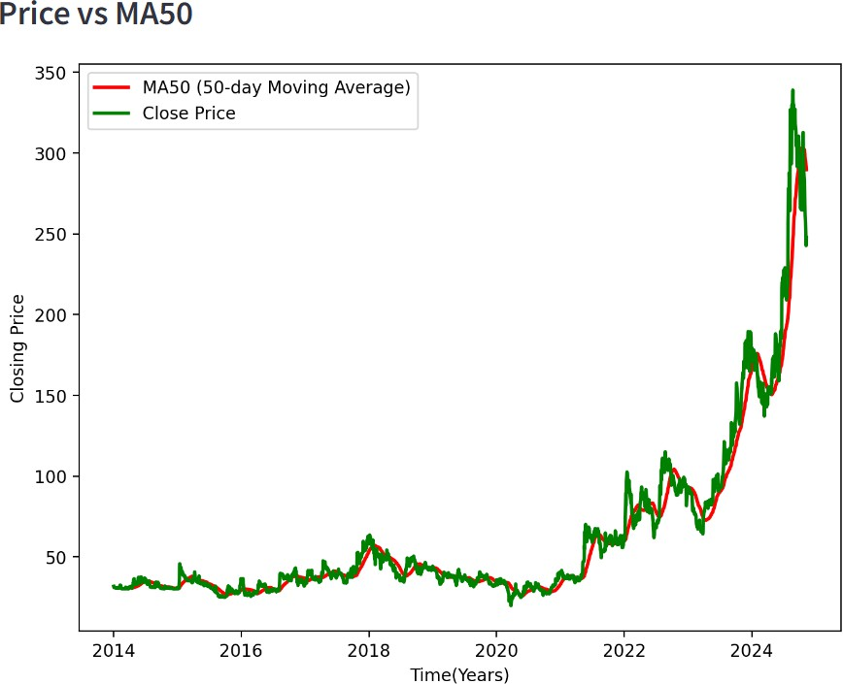

Figure1

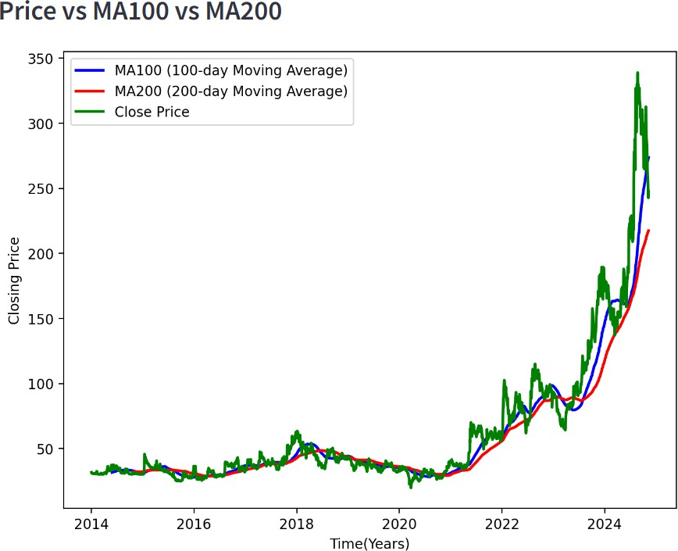

Figure 3

# **RESULT**

Once the model is trained, the input data is fed to the model and tested. The data is used from the remaining 20% of the dataset which is new and unseen data for model. On the basis of training of model on the dataset of stock selected by user, it will predict the closing price of the stock. We have trained the model from a time range of January 1,2014 to November 2022, now from that time series till now the model will predict the closing price of the stock on the basis of training.

For example: If today is January 1, 2025, we give the model input prices from September to December 2024.The model uses these prices to predict what might happen on January 2, 2025.After training, we can test the model by comparing its predictions to actual prices and plot the results between Original Price and Predicted Price of the stock.

Mean Absolute Percentage Error (MAPE) and Mean Squared Error (MSE) are used as metrics to evaluate prediction accuracy. Lower MAPE and MSE values indicate higher prediction accuracy. The closer these values are to zero, the better the model has observed and learned stock price patterns.

We have plotted a graph between Original Price and Predicted Price by the model, which shows the model accuracy with the help of graph. More the line of Original Closing Price of stock is closed to the line of Predicted Closing Price, the more accurate will be the model.

Few examples has been shown below of few company with accuracy.

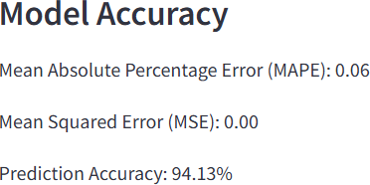

Figure 6 Line graph b/w Original Price and Predicted Price of Adani Green Energy along with Model Accuracy

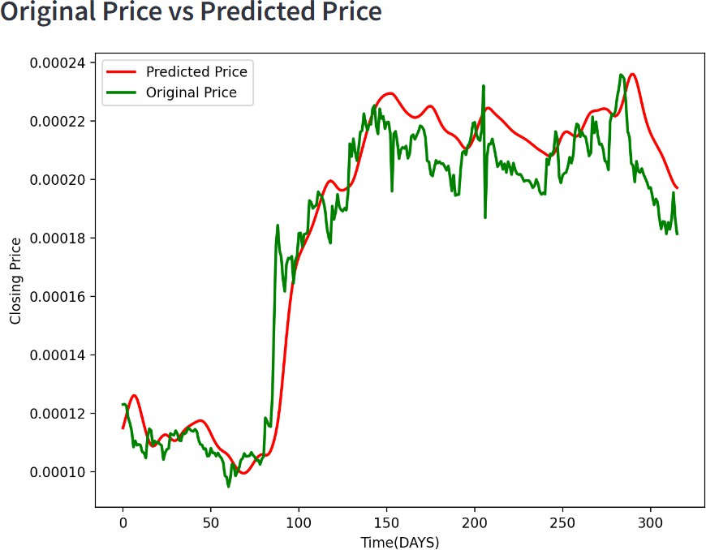

ADANI GREEN ENERGY

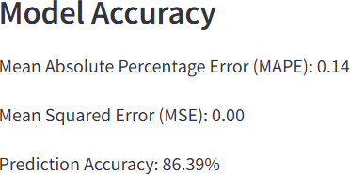

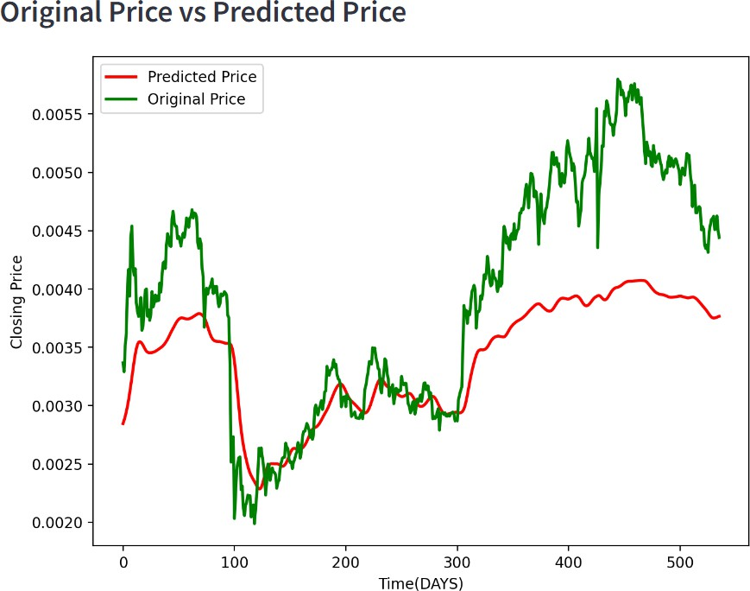

AMBUJA CEMENTS LTD

Figure 7 Line graph b/w Original Price and Predicted Price of Ambuja Cements ltd. along with Model Accuracy

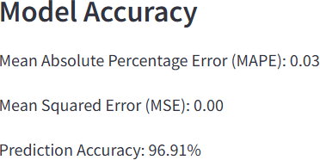

Figure 8 Line graph b/w Original Price and Predicted Price of Bajaj FInance ltd. along with Model Accuracy

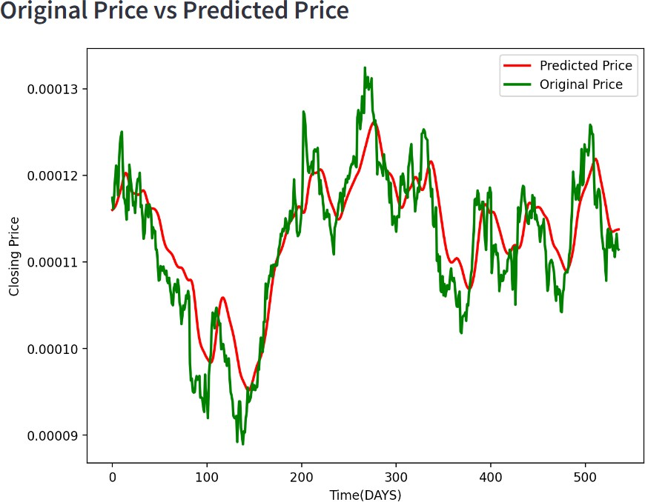

BAJAJ FINANCE LIMITED

**Conclusion and future scope**

In this project, we deployed a model based on Long Short-Term Memory (LSTM) technology, specifically designed for forecasting stock prices by taking the help of historical market data collected over time. We made good use of the natural capabilities and strengths of LSTM networks. Hence, our model indicated excellent capabilities to identify and analyze complex patterns of the stock market, rendering it highly effective for the task of short-term forecasting along with predictions of closing prices. The model has been very well trained with varied stock attributes, including essential attributes like the opening price of stocks, the closing price at the end of trading session of the day, the highest price achieved in a day, the lowest price recorded, and the number of shares traded(volume). Further, performance metrics have been used to analyze the effectiveness of the model by considering RMSE and MAPE, both of which were very promising. The tremendous potential that deep learning models can offer in giving reliable financial forecasts in the stock market is reflected in the close alignment observed between the stock prices predicted by the model and the actual stock prices.

Prospects for the Future while this is an excellent foundation, many avenues of improvement exist. For one, adding features like technical indicators, for example, Moving Averages and RSI will improve the model even more. Indeed, results could improve if a more complex architecture, such as an attention mechanism or even a hybrid model combining LSTM with some other deep learning technique, such as CNNs or reinforcement learning, were employed. Moreover, increasing the scope of the present model, so as to predict stock prices, not only in one sector but also across multiple sectors or even across many international markets, would be immensely valuable. Conclusion exploring inclusions of real-time data and developing the model further as an automated trading system would prove to be highly useful exercises because these methods would offer hands-on direct stock prediction capabilities that would help investors and analysts massively.

**References**

[1] Stock Closing Price Prediction using Machine Learning Techniques Mehar Vijha , Deeksha Chandolab, Vinay Anand Tikkiwalb, Arun Kumar ,Jaypee Institute Of Information Technology, Noida 201304, India Department of Electronics and Communication Engineering, Jaypee Institute Of Information Technology, Noida 201304, India c Department of Computer Science and Engineering, National Institute of Technology, Rourkela, 769008, India.

[2] Yahoo Finance - Business Finance Stock Market News, [ Accessed on August 16,2018]

[3] Selvin, Sreelekshmy, R. Vinayakumar, E. A. Gopalakrishnan, Vijay Krishna Menon, and K. P. Soman. (2017) “Stock price prediction using LSTM, RNN and CNN-sliding window mode.” International Conference on Advances in Computing, Communications and Informatics (ICACCI)

[4] M. Usmani, S. H. Adil, K. Raza and S. S. A. Ali, "Stock market prediction using machine learning techniques", 2016 3rd International Conference on Computer and Information Sciences (ICCOINS), pp. 322-327, 2016.

[5] Fischer, T., & Krauss, C. (2018) “*Deep Learning with Long Short-Term Memory Networks for Financial Market . Predictions”*

[6]Zhang, X., Aggarwal, S., & Maheshwari, S. (2020) Title: *Enhancing Stock Price Prediction Accuracy Using Attention- . Based LSTMs*

[7] Patel, J., Shah, S., Thakkar, P., & Kotecha, K. (2015)Title: *Predicting Stock Market Index Using Fusion of Machine Learning Techniques*

[8] Ghosh, S., & Ghosh, M. (2021) Title: *Application of LSTM in Predicting Stock Prices Based on News Sentiment Analysis*